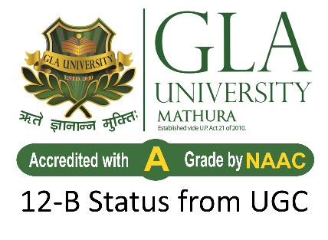

Project Title: GLA Event Management System
C# .NET Mini-Project
Institution Name: GLA University, Mathura
Course: B.Tech - Computer Science & Engineering
Year & Semester: 3rd Year - VI Sem
Submitted to: Mr. Ayush Tiwari

Submitted by:

NAME UNIVERSITY ROLL.NO
Vishu Sharma 2315002496
Ipshita Gupta 2315000989
Prince Sharma 2315001685
Shadab Alam 2315002021

GLA Event Management System

1. Introduction
GLA Events is a secure digital event ticketing system developed for GLA University. The system allows students to purchase event tickets online and use secure QR codes for entry. It eliminates manual ticketing, prevents ticket resale, and ensures fast and controlled event access.

2. Problem Statement
Currently, event ticketing systems may face issues such as:
- Ticket duplication or resale
- Slow manual entry verification
- Lack of secure student authentication
- Poor event management tracking
A secure and automated system is required to ensure transparency, safety, and efficiency.

3. Objective
The main objectives of the system are:
- To allow only GLA students to purchase tickets
- To provide secure login using GLA email
- To enable admins to manage events easily
- To generate time-limited QR codes for secure entry
- To prevent ticket reuse and resale
- To ensure fast ticket validation at event entry

4. Proposed System
The proposed system is a mobile-based application with an integrated backend system.
Key Functionalities:
Student:
- Login using GLA email (Google OAuth)
- Purchase tickets through Razorpay
- Receive a time-limited QR code at event entry
- Each ticket usable only once
Admin:
- Create and manage events
- Set event date, time, price, and capacity
- Enable/disable ticket sales
Guard:
- Scan QR codes at entry
- Validate ticket authenticity
- Reject expired or reused QR codes

5. Technology Used
- Frontend: Flutter (Android/iOS)
- Backend: .NET
- Database: PostgreSQL
- Cache: Redis
- Authentication: Google OAuth (GLA domain restricted)
- Payment Gateway: Razorpay
- Server: Nginx
- Deployment: Docker Containers

6. Security Features
- Login restricted to GLA email IDs only
- Secure HTTPS communication
- Time-bound (10 seconds) QR codes
- Single-use ticket validation
- Authenticated API access
- Encrypted data transmission

7. Non-Functional Requirements
- QR validation within 2 seconds
- Payment confirmation within 5 seconds
- High reliability during events
- Scalable to handle multiple users
- Automatic database backup and audit logs

8. Conclusion
GLA Events provides a secure, efficient, and fully digital solution for event ticketing at GLA University. The system enhances security, prevents fraud, ensures smooth entry management, and improves overall event organization.

